**Introduction .Net**

1. .Net ?

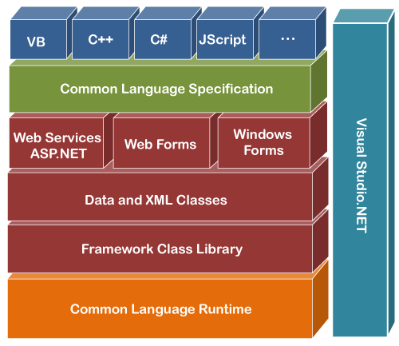

* 1. .Net is a Software Development **Framework**.
     1. Framework ?
        1. If I want to Develop Web Application , Then Framework is a **Frame** that Provides All **required tools** during Work.
        2. Its Pre Defined Frame in Which I can work , with some limitation
           1. Like hum PHP me dot_net use nhin kr sktaa
  2. What can we do with .net Framework ?
     1. We Can Create various type of **Application**
        1. Console Application
        2. GUI Application
           1. Windows Application
           2. Web application

Asp .net

Asp.net MVC

* + - * 1. Mobile Application

Xamarin

* + 1. We Can Create Services
       1. Web Services
       2. WCF services
       3. API services
    2. We can Create our Custom libraries As well As.

1. What is **Libraries?**
   1. Libraries mean pre-defined files and Archetectures which help us to create particular Application.
      1. Let Examples
         1. Console.writeLine(“”) 🡨--- this will print text on Console
            1. Console.writeline is a predefined object which is written

**System** library

1. What is **Runtime?** 
   1. Run Time Environment CLR (common language runtime)
      1. CLR is Virtual machine Component of Micro .net
      2. Manages the execution of .Net Framework
2. What is **JIT** (just in time) ?
   1. **JIT is a Compiler** which is a part **(component) of CLR.**
   2. Basically the main work is Depend on this JIT.
   3. Basically it **Converts Microsoft Intermediate Language** in to Machen language or Native language Computer understand only **Binary language or Native language**.

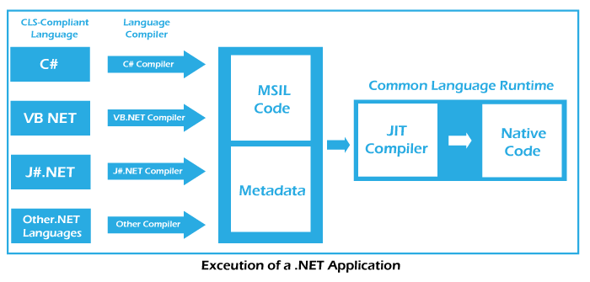

1. **MSIL ?** 
   1. MSIL stand for **Microsoft Intermediate language.**
   2. C# compiler **Can not Directly** convert our Code into **Matchine lanaguge**
   3. C# convert **Human instruction** into **MSIL or Metadata**
   4. Then **CLR (JIT)** convert **MSIL to Native Language**
2. **.Net Language**
   1. **.Net is a software framework which 3 Langeus**
      1. **C#**
      2. **F#**
      3. **Visual Basic**

**These are supported Microsoft Language**

1. **SDK ?**
   1. **Software Development Kit**
   2. **provides the tools for programming**
   3. **Example :**
      1. **If We Want to use 3.1 .net Core Version**

**So we have to download SDK for that. Because all Tools are available in SDK for .net core 3.1.**

1. **IDE** (Integrated Development Environments)
   1. After **Download SDK** we Need a Place Where We Can use This SDK Tools .
   2. Its Basically Interface to interact with SDK tools to Develop application.
   3. **An IDE only provides an interface.**
   4. **Visual Studio** 
      1. **Versions**
         1. **1st ver 🡪 VS.Net**

**.Net Core Vs .Net**

**.Net**

1. Released in **13-Feb-2002** version **1.0**
2. Last version of .net was **4.6** released in **20-aug-2015**

**.Net Core**

1. Released in **June 27, 2016** version **1.0**
2. Latest Version of .net core is **.Net 7.0** November 12, 2024
3. **But LTS is .Net 6.0**

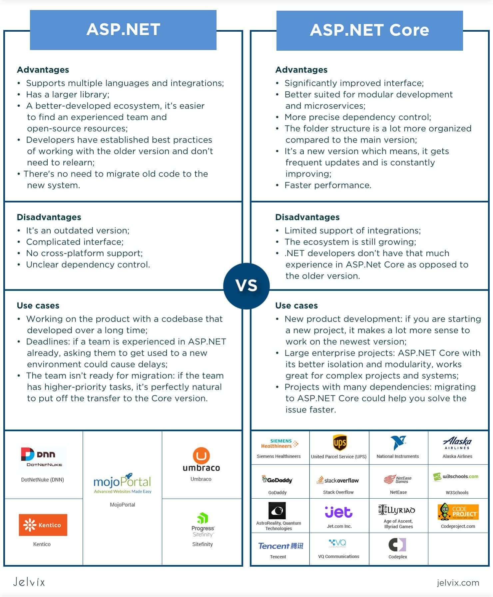

**.Net Vs asp .net**

**.Net**

1. .Net is Complete structure

**Asp .Net**

1. Asp.Net is Component of .Net
2. Asp.Net is used to develop only Web Application
   1. Web Forms
   2. Asp.net MVC
   3. Asp.Net web pages

**LINQ (Language integrated Query)**

1. Language Integrated Query is a Microsoft .NET Framework component that adds native data querying capabilities to .NET languages, originally released as a major part of .NET Framework 3.5 in 2007
2. Similar like SQL Query
3. Its used To Rederive any Object Values base on condition
   1. Select
   2. Where
   3. Joins

